

SOFTWARE DESIGN SPECIFICATION
Project Name: Ralsei Coach House System

– Hanoi, May 2026 –

Table of Contents
I. Record of Changes 3
II. Software Design Document 4
1. High Level Design 4
1.1 Software Architecture 4
1.2 Package Diagram 5
1.3 Database Design 6
2. State Transition Diagrams 8
2.1 PIN Validation 8
2.2 … 8
3. Detailed Design 9
3.1 <Feature/Function Name1> 9
3.2 <Feature/Function Name2> 10

I. Record of Changes
Date | A*  M, D | In charge | Change Description
25/6 | A | Hà | 1.1. Software Architecture
25/6 | A | Đức | 1.2. Package Diagram
25/6 | A | Trung | 1.3. Database Design
*A - Added M - Modified D - Deleted

II. Software Design Document

1. High Level Design

1.1 Software Architecture
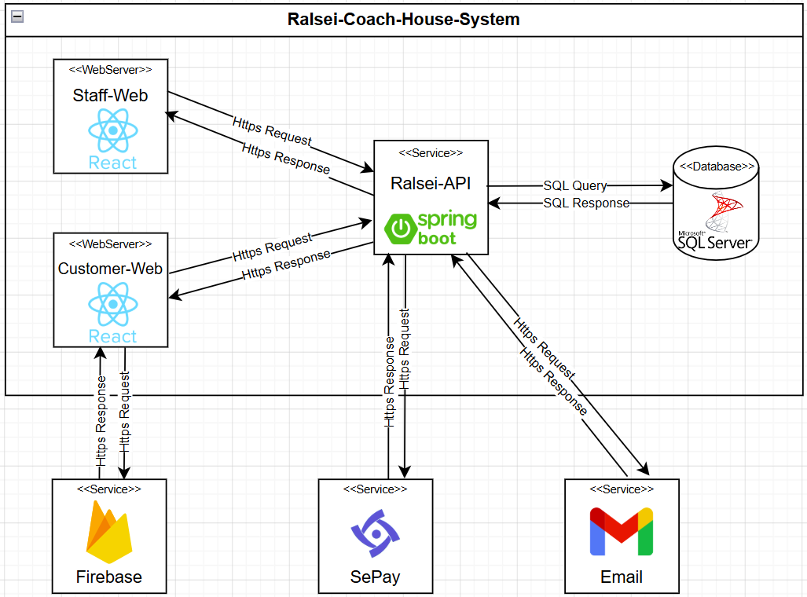

No | Sub-system | Description
01 | API Service | Backend service developed using Spring Boot that provides RESTful APIs for business operations such as user management, ticket booking, payment processing, trip management, and communication with external services.
02 | Customer Website | React-based web application that allows customers to register, authenticate, search routes, book tickets, make payments, view booking history, and manage personal information.
03 | Staff Website | React-based web application used by staff members to manage routes, schedules, vehicles, bookings, customer information, and operational activities of the bus transportation system.
04 | Database | Centralized data storage system responsible for persisting application data, including user accounts, bookings, tickets, routes, schedules, payments, and system configurations.
05 | External Authentication Service | Third-party authentication service (Firebase Authentication) used for customer login, registration, identity verification, and secure token management.
06 | External Payment Service | Third-party payment service (SePay) used to process online payments, generate payment requests, and notify the system of successful payment transactions through webhooks.
07 | External Email Service | Third-party email service used to send notifications such as booking confirmations, payment confirmations, ticket updates, and other customer-related communications.

1.2 Package Diagram
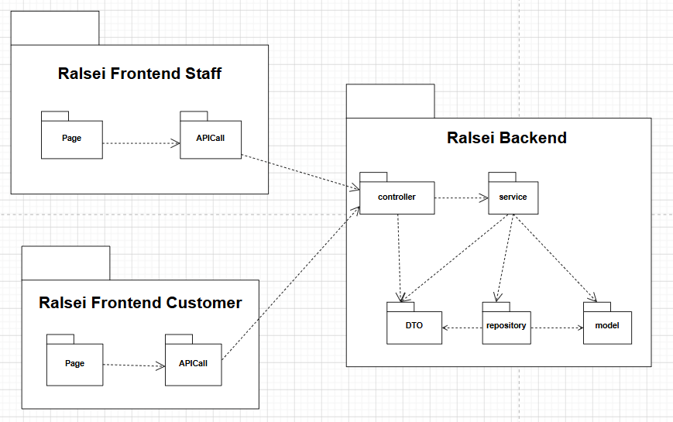

Package descriptions
No | Package | Description
01 | Model | Defines the data entities that map directly to the database tables, managing the core state and business rules of domain objects.
02 | Controller | Intercepts incoming requests from clients, delegates processing to the appropriate services, and returns the formatted responses.
03 | DTO | Encapsulates data structures optimized for transferring data between layers or network boundaries, ensuring internal model encapsulation and security.
04 | Service | Contains the core business logic of the application, orchestrating complex workflows and managing transaction boundaries.
05 | Repository | Provides an abstraction layer for database access, handling data persistence, CRUD operations, and execution of database queries.
06 | Page | Provides an abstraction layer for database access, handling data persistence, CRUD operations, and execution of database queries.
07 | API | Exposes RESTful endpoints to enable integration for single-page applications (SPAs), mobile clients, or third-party external systems.

1.3 Database Design
[Provide the files description, database table relationship & table descriptions like example below]
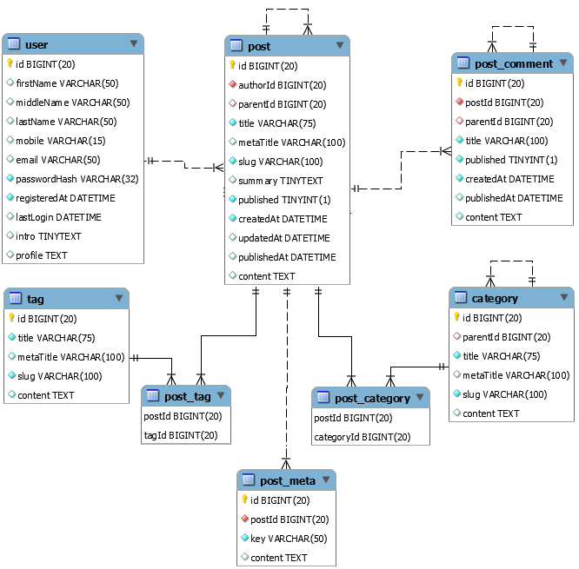

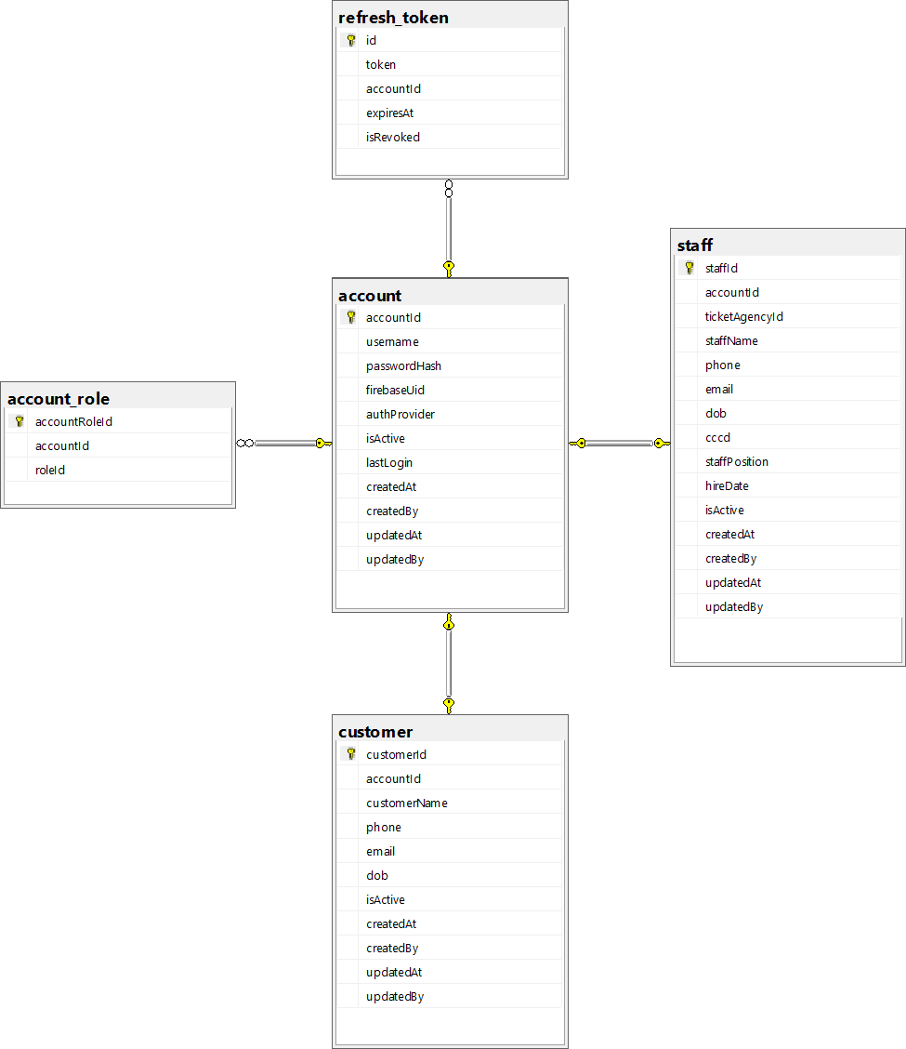
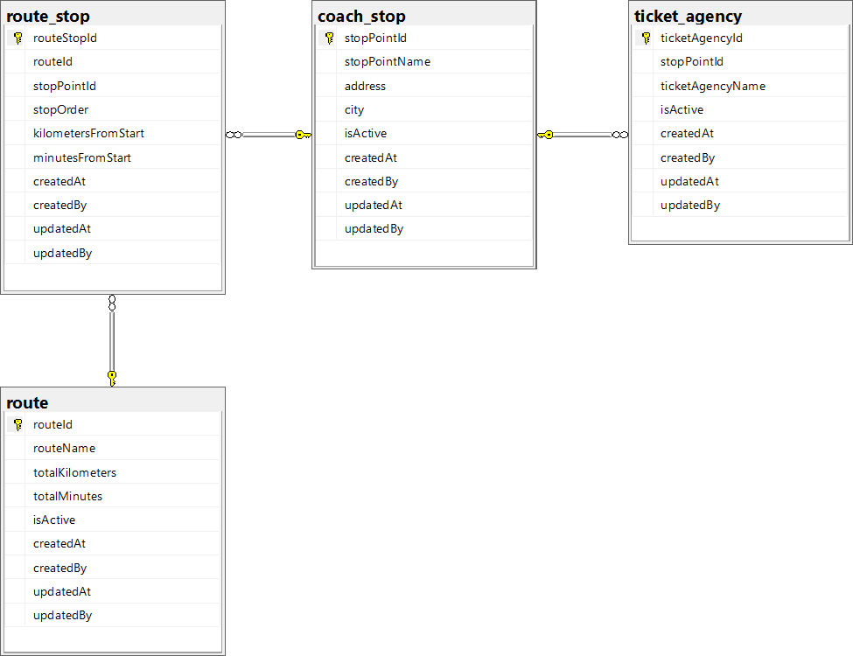
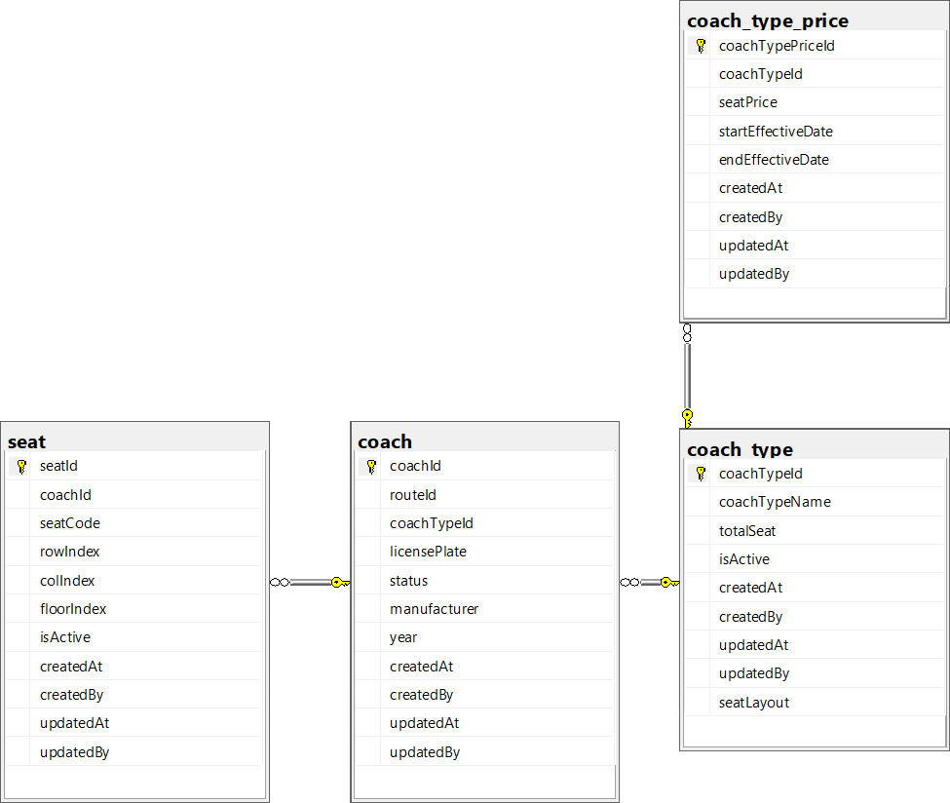
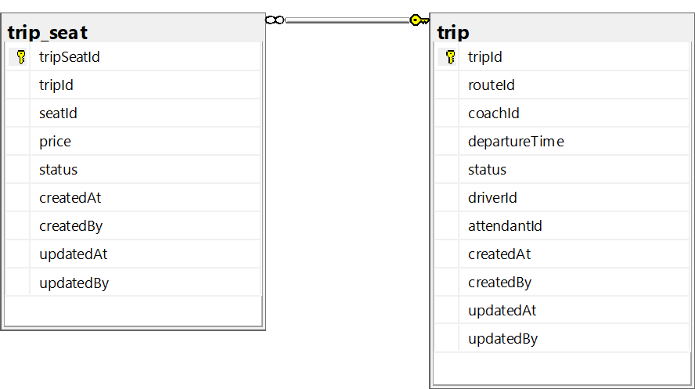
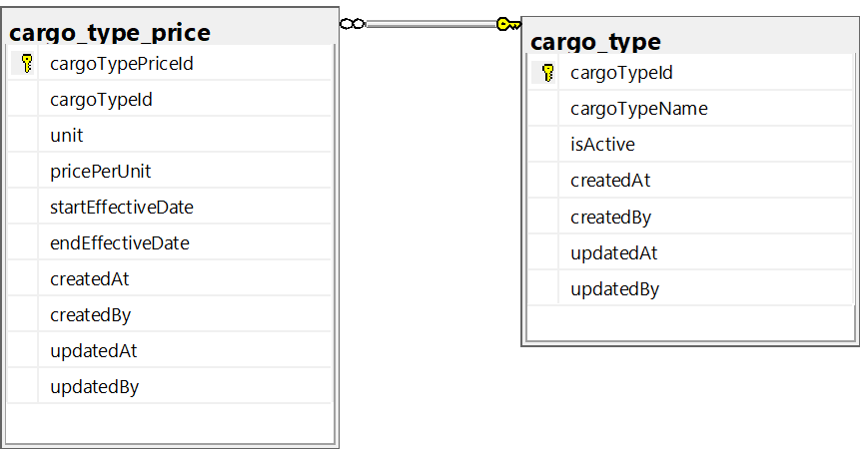
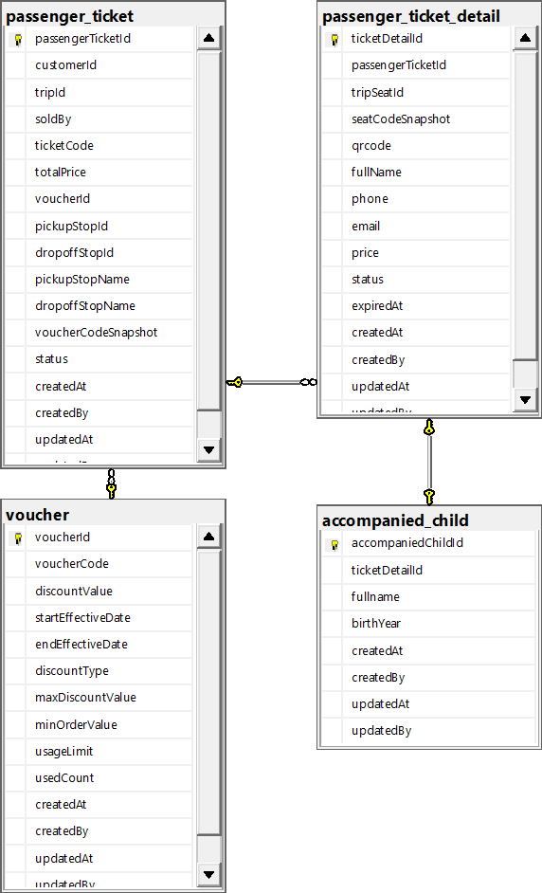

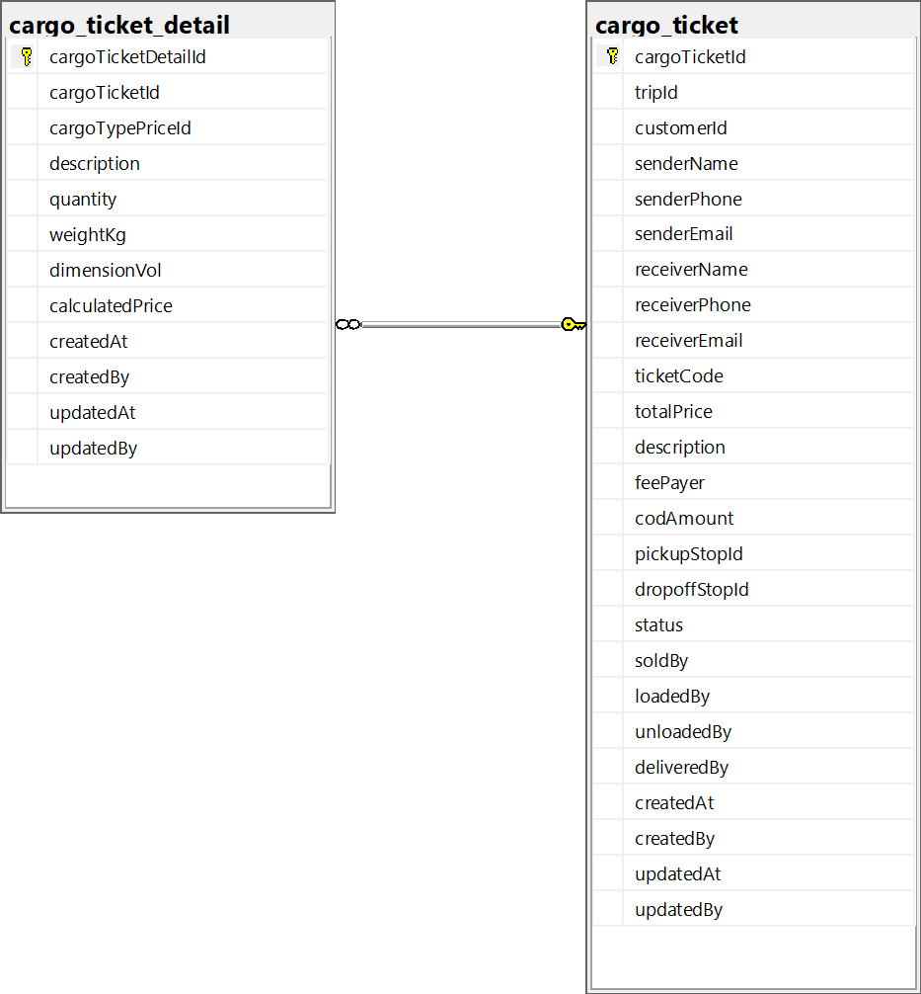
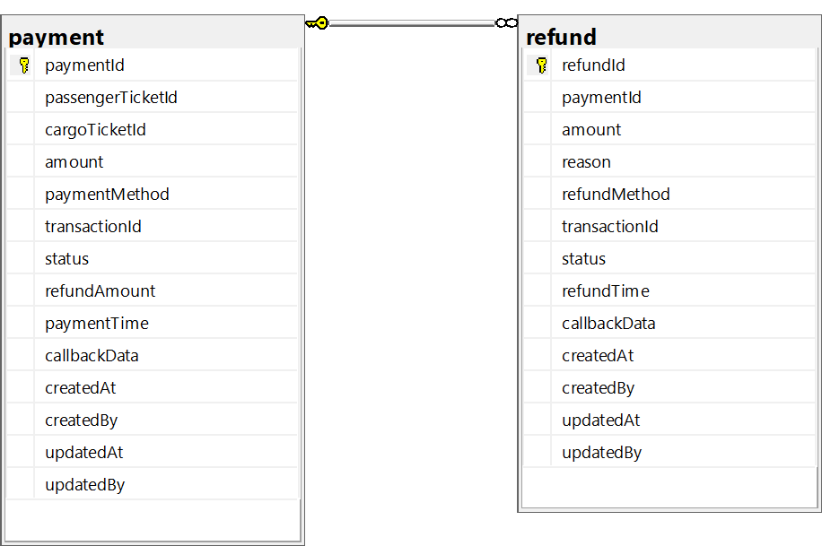

1.3.1 account
Stores login credentials and authentication metadata for every system user (Staff via local username/password, Customers via Firebase/Google/Facebook). One account is shared by exactly one staff or one customer profile.
No | Field | PK | FK | UN | NN | Description
1 | accountId | X |  |  | X | Surrogate primary key, auto-incremented.
2 | username |  |  | X | X | Login identifier; for Staff it is a phone number, for form-based Customers it is also a phone number, and for Firebase/Google/Facebook Customers it can be the provider email or Firebase UID.
3 | passwordHash |  |  |  |  | Bcrypt hash of the password (Staff accounts only; NULL for Firebase-based Customers).
4 | firebaseUid |  |  | X |  | Firebase UID for Customers authenticating via Firebase/Google/Facebook; NULL for Staff. Enforced unique only when not NULL (filtered unique index).
5 | authProvider |  |  |  | X | Authentication source: ’local’ (Staff), ’firebase’, ’google’, or ’facebook’ (Customer).
6 | isActive |  |  |  | X | Soft-delete / lock flag; 1 = active, 0 = disabled.
7 | lastLogin |  |  |  |  | Timestamp of the most recent successful login.
8 | createdAt |  |  |  |  | Record creation timestamp, defaults to current date/time.
9 | createdBy |  |  |  |  | Id of the account that created this record.
10 | updatedAt |  |  |  |  | Record last-update timestamp, defaults to current date/time.
11 | updatedBy |  |  |  |  | Id of the account that last updated this record.

1.3.2 role
Lookup table of system roles (e.g. Admin, Manager, Ticket Staff, Driver, Attendant) that can be assigned to one or more accounts through account_role.
No | Field | PK | FK | UN | NN | Description
1 | roleId | X |  |  | X | Surrogate primary key, auto-incremented.
2 | roleName |  |  | X | X | Display name of the role.
3 | isActive |  |  |  | X | Whether the role can still be assigned/used.
4 | createdAt |  |  |  |  | Record creation timestamp.
5 | createdBy |  |  |  |  | Id of the account that created this record.
6 | updatedAt |  |  |  |  | Record last-update timestamp.
7 | updatedBy |  |  |  |  | Id of the account that last updated this record.

1.3.3 voucher
Discount codes that customers can apply to a passenger or cargo ticket at checkout, either as a percentage or a fixed amount, within an effective date range and usage limit.
No | Field | PK | FK | UN | NN | Description
1 | voucherId | X |  |  | X | Surrogate primary key, auto-incremented.
2 | voucherCode |  |  | X | X | Unique code customers enter to redeem the voucher.
3 | discountValue |  |  |  | X | Discount amount; interpreted as a percentage or a fixed amount depending on discountType.
4 | startEffectiveDate |  |  |  | X | Date/time from which the voucher can be used.
5 | endEffectiveDate |  |  |  | X | Date/time after which the voucher can no longer be used; must be on or after startEffectiveDate.
6 | discountType |  |  |  | X | Discount mode: ’PERCENT’ or ’FIXED’.
7 | maxDiscountValue |  |  |  | X | Upper cap applied to the computed discount when discountType is ’PERCENT’.
8 | minOrderValue |  |  |  | X | Minimum order total required to apply the voucher.
9 | usageLimit |  |  |  | X | Maximum number of times the voucher may be redeemed in total; 0 means unlimited.
10 | usedCount |  |  |  | X | Running count of how many times the voucher has been redeemed so far.
11 | createdAt |  |  |  |  | Record creation timestamp.
12 | createdBy |  |  |  |  | Id of the account that created this record.
13 | updatedAt |  |  |  |  | Record last-update timestamp.
14 | updatedBy |  |  |  |  | Id of the account that last updated this record.

1.3.4 coach_stop
Master list of physical pickup/drop-off locations (bus stops, stations) used to build routes and as pickup/drop-off points on tickets.
No | Field | PK | FK | UN | NN | Description
1 | stopPointId | X |  |  | X | Surrogate primary key, auto-incremented.
2 | stopPointName |  |  |  | X | Display name of the stop point.
3 | address |  |  |  | X | Street address of the stop point.
4 | city |  |  |  | X | City/province in which the stop point is located.
5 | isActive |  |  |  | X | Whether the stop point is currently in use.
6 | createdAt |  |  |  |  | Record creation timestamp.
7 | createdBy |  |  |  |  | Id of the account that created this record.
8 | updatedAt |  |  |  |  | Record last-update timestamp.
9 | updatedBy |  |  |  |  | Id of the account that last updated this record.

1.3.5 route
Master list of coach routes, each with a total distance and total scheduled duration; a route is later broken into ordered stops (route_stop) and assigned to actual trips.
No | Field | PK | FK | UN | NN | Description
1 | routeId | X |  |  | X | Surrogate primary key, auto-incremented.
2 | routeName |  |  |  | X | Display name of the route (e.g. origin – destination).
3 | totalKilometers |  |  |  | X | Total distance of the route in kilometers; must be greater than 0.
4 | totalMinutes |  |  |  | X | Total scheduled travel time of the route in minutes; must be greater than 0.
5 | isActive |  |  |  | X | Whether the route is currently offered.
6 | createdAt |  |  |  |  | Record creation timestamp.
7 | createdBy |  |  |  |  | Id of the account that created this record.
8 | updatedAt |  |  |  |  | Record last-update timestamp.
9 | updatedBy |  |  |  |  | Id of the account that last updated this record.

1.3.6 coach_type
Master list of coach (vehicle) categories, e.g. Sleeper 40-seat, Limousine 9-seat, each defining a total seat count and a seat layout used to generate the actual seat map for coaches of that type.
No | Field | PK | FK | UN | NN | Description
1 | coachTypeId | X |  |  | X | Surrogate primary key, auto-incremented.
2 | coachTypeName |  | X (Unique) | X | X | Display name of the coach type; must be unique.
3 | totalSeat |  |  |  | X | Total number of seats for this coach type; must be greater than 0.
4 | isActive |  |  |  | X | Whether the coach type is still in use.
5 | createdAt |  |  |  |  | Record creation timestamp.
6 | createdBy |  |  |  |  | Id of the account that created this record.
7 | updatedAt |  |  |  |  | Record last-update timestamp.
8 | updatedBy |  |  |  |  | Id of the account that last updated this record.
9 | seatLayout |  |  |  |  | JSON/text definition describing the physical seat grid (rows, columns, floors) used to generate individual seat rows for coaches of this type.

1.3.7 cargo_type
Master list of cargo categories used to classify shipped goods (e.g. document, fragile, bulky) and to look up the applicable per-unit price via cargo_type_price.
No | Field | PK | FK | UN | NN | Description
1 | cargoTypeId | X |  |  | X | Surrogate primary key, auto-incremented.
2 | cargoTypeName |  |  |  | X | Display name of the cargo type.
3 | isActive |  |  |  | X | Whether the cargo type is currently offered.
4 | createdAt |  |  |  |  | Record creation timestamp.
5 | createdBy |  |  |  |  | Id of the account that created this record.
6 | updatedAt |  |  |  |  | Record last-update timestamp.
7 | updatedBy |  |  |  |  | Id of the account that last updated this record.

1.3.8 account_role
Associative table implementing the many-to-many relationship between account and role; one account may hold multiple roles, and one role may be held by multiple accounts.
No | Field | PK | FK | UN | NN | Description
1 | accountRoleId | X |  |  | X | Surrogate primary key, auto-incremented.
2 | accountId |  | X |  | X | References account.accountId; the account being granted the role.
3 | roleId |  | X |  | X | References role.roleId; the role granted to the account.

1.3.9 customer
Profile of a registered passenger/shipper. accountId is nullable to support walk-in (guest) customers who have not registered an account but still need a record for tickets/orders.
No | Field | PK | FK | UN | NN | Description
1 | customerId | X |  |  | X | Surrogate primary key, auto-incremented.
2 | accountId |  | X | X |  | References account.accountId; NULL for walk-in/guest customers who have no login account. Set to NULL automatically if the linked account is deleted.
3 | customerName |  |  |  | X | Full name of the customer.
4 | phone |  |  |  |  | Contact phone number.
5 | email |  |  |  |  | Contact email address.
6 | dob |  |  |  |  | Date of birth.
7 | isActive |  |  |  | X | Whether the customer profile is active.
8 | createdAt |  |  |  |  | Record creation timestamp.
9 | createdBy |  |  |  |  | Id of the account that created this record.
10 | updatedAt |  |  |  |  | Record last-update timestamp.
11 | updatedBy |  |  |  |  | Id of the account that last updated this record.

1.3.10 ticket_agency
Physical ticket-selling office/counter located at a coach_stop; staff assigned to an agency sell passenger and cargo tickets from that location.
No | Field | PK | FK | UN | NN | Description
1 | ticketAgencyId | X |  |  | X | Surrogate primary key, auto-incremented.
2 | stopPointId |  | X |  | X | References coach_stop.stopPointId; the stop point where the agency is physically located.
3 | ticketAgencyName |  |  |  | X | Display name of the ticket agency.
4 | isActive |  |  |  | X | Whether the agency is currently operating.
5 | createdAt |  |  |  |  | Record creation timestamp.
6 | createdBy |  |  |  |  | Id of the account that created this record.
7 | updatedAt |  |  |  |  | Record last-update timestamp.
8 | updatedBy |  |  |  |  | Id of the account that last updated this record.

1.3.11 staff
Profile of an internal employee (driver, attendant, ticket staff, manager). accountId and ticketAgencyId are nullable to support drivers/attendants who have no login account and are not tied to a fixed agency.
No | Field | PK | FK | UN | NN | Description
1 | staffId | X |  |  | X | Surrogate primary key, auto-incremented.
2 | accountId |  | X | X |  | References account.accountId; NULL while the staff member has not yet been onboarded with login credentials.
3 | ticketAgencyId |  | X |  |  | References ticket_agency.ticketAgencyId; NULL for drivers/attendants who are not based at a fixed ticket counter. Set to NULL automatically if the agency is deleted.
4 | staffName |  |  |  | X | Full name of the staff member.
5 | phone |  |  |  | X | Contact phone number.
6 | email |  |  |  |  | Contact email address.
7 | dob |  |  |  |  | Date of birth.
8 | cccd |  |  |  |  | National ID card number.
9 | staffPosition |  |  |  | X | Job role: ’DRIVER’, ’ATTENDANT’, ’TICKET_STAFF’, or ’MANAGER’.
10 | hireDate |  |  |  | X | Date the staff member was hired.
11 | isActive |  |  |  | X | Whether the staff member is currently employed/active.
12 | createdAt |  |  |  |  | Record creation timestamp.
13 | createdBy |  |  |  |  | Id of the account that created this record.
14 | updatedAt |  |  |  |  | Record last-update timestamp.
15 | updatedBy |  |  |  |  | Id of the account that last updated this record.

1.3.12 route_stop
Associative table that orders coach_stop entries along a route, recording the cumulative distance/time of each stop from the start of the route.
No | Field | PK | FK | UN | NN | Description
1 | routeStopId | X |  |  | X | Surrogate primary key, auto-incremented.
2 | routeId |  | X |  | X | References route.routeId; the route this stop belongs to.
3 | stopPointId |  | X |  | X | References coach_stop.stopPointId; the physical stop at this position.
4 | stopOrder |  |  |  | X | Sequence number of the stop along the route (1, 2, 3, …); must be at least 1.
5 | kilometersFromStart |  |  |  | X | Cumulative distance from the route’s first stop, in kilometers.
6 | minutesFromStart |  |  |  | X | Cumulative travel time from the route’s first stop, in minutes.
7 | createdAt |  |  |  |  | Record creation timestamp.
8 | createdBy |  |  |  |  | Id of the account that created this record.
9 | updatedAt |  |  |  |  | Record last-update timestamp.
10 | updatedBy |  |  |  |  | Id of the account that last updated this record.

1.3.13 coach_type_price
Historical price list for a coach_type’s seats, keyed by an effective-date range, allowing prices to change over time while preserving past pricing for snapshots.
No | Field | PK | FK | UN | NN | Description
1 | coachTypePriceId | X |  |  | X | Surrogate primary key, auto-incremented.
2 | coachTypeId |  | X |  | X | References coach_type.coachTypeId; the coach type this price applies to.
3 | seatPrice |  |  |  | X | Price of a single seat of this coach type during the effective period.
4 | startEffectiveDate |  |  | X (with coachTypeId) | X | Date/time from which this price takes effect; combined with coachTypeId must be unique to prevent duplicate price entries.
5 | endEffectiveDate |  |  |  | X | Date/time until which this price remains effective; must be on or after startEffectiveDate.
6 | createdAt |  |  |  |  | Record creation timestamp.
7 | createdBy |  |  |  |  | Id of the account that created this record.
8 | updatedAt |  |  |  |  | Record last-update timestamp.
9 | updatedBy |  |  |  |  | Id of the account that last updated this record.

1.3.14 cargo_type_price
Historical price list for a cargo_type, defining the price per measurement unit (kg, m3, piece, etc.) during an effective-date range.
No | Field | PK | FK | UN | NN | Description
1 | cargoTypePriceId | X |  |  | X | Surrogate primary key, auto-incremented.
2 | cargoTypeId |  | X |  | X | References cargo_type.cargoTypeId; the cargo type this price applies to.
3 | unit |  |  |  | X | Measurement unit the price is quoted in, e.g. kg, m3, piece.
4 | pricePerUnit |  |  |  | X | Price charged per unit during the effective period.
5 | startEffectiveDate |  |  |  | X | Date/time from which this price takes effect.
6 | endEffectiveDate |  |  |  | X | Date/time until which this price remains effective; must be on or after startEffectiveDate.
7 | createdAt |  |  |  |  | Record creation timestamp.
8 | createdBy |  |  |  |  | Id of the account that created this record.
9 | updatedAt |  |  |  |  | Record last-update timestamp.
10 | updatedBy |  |  |  |  | Id of the account that last updated this record.

1.3.15 coach
A physical vehicle of a given coach_type, optionally assigned to a fixed route, whose individual seats are generated into the seat table.
No | Field | PK | FK | UN | NN | Description
1 | coachId | X |  |  | X | Surrogate primary key, auto-incremented.
2 | routeId |  | X |  |  | References route.routeId; the route the coach is currently assigned to, if any.
3 | coachTypeId |  | X |  | X | References coach_type.coachTypeId; defines the seat layout/capacity of the vehicle.
4 | licensePlate |  |  | X | X | Vehicle license plate number; must be unique.
5 | status |  |  |  | X | Operating status: ’ACTIVE’, ’MAINTENANCE’, or ’RETIRED’.
6 | manufacturer |  |  |  |  | Vehicle manufacturer/brand.
7 | year |  |  |  |  | Manufacturing year of the vehicle.
8 | createdAt |  |  |  |  | Record creation timestamp.
9 | createdBy |  |  |  |  | Id of the account that created this record.
10 | updatedAt |  |  |  |  | Record last-update timestamp.
11 | updatedBy |  |  |  |  | Id of the account that last updated this record.

1.3.16 seat
Individual physical seat belonging to a coach, positioned by row/column/floor according to the coach’s coach_type seat layout.
No | Field | PK | FK | UN | NN | Description
1 | seatId | X |  |  | X | Surrogate primary key, auto-incremented.
2 | coachId |  | X |  | X | References coach.coachId; the vehicle this seat belongs to.
3 | seatCode |  |  | X (with coachId) | X | Human-readable seat label (e.g. A01); combined with coachId must be unique.
4 | rowIndex |  |  | X (with coachId, floorIndex, colIndex) | X | Row position of the seat within the coach; must be at least 1.
5 | colIndex |  |  | X (with coachId, floorIndex, rowIndex) | X | Column position of the seat within the coach; must be at least 1.
6 | floorIndex |  |  | X (with coachId, rowIndex, colIndex) | X | Floor/deck the seat is on (e.g. 1 = lower deck, 2 = upper deck).
7 | isActive |  |  |  | X | Whether the seat is currently usable (not blocked/out of service).
8 | createdAt |  |  |  |  | Record creation timestamp.
9 | createdBy |  |  |  |  | Id of the account that created this record.
10 | updatedAt |  |  |  |  | Record last-update timestamp.
11 | updatedBy |  |  |  |  | Id of the account that last updated this record.

1.3.17 trip
A scheduled, actual run of a coach over a route at a specific departure time, with an assigned driver and attendant.
No | Field | PK | FK | UN | NN | Description
1 | tripId | X |  |  | X | Surrogate primary key, auto-incremented.
2 | routeId |  | X |  | X | References route.routeId; the route this trip runs.
3 | coachId |  | X |  | X | References coach.coachId; the vehicle assigned to this trip.
4 | departureTime |  |  |  | X | Scheduled departure date/time of the trip.
5 | status |  |  |  | X | Trip status: ’SCHEDULED’, ’IN_PROGRESS’, ’CANCELLED’, or ’COMPLETED’.
6 | driverId |  | X |  |  | References staff.staffId; the driver assigned to the trip; must differ from attendantId.
7 | attendantId |  | X |  |  | References staff.staffId; the attendant assigned to the trip; must differ from driverId.
8 | createdAt |  |  |  |  | Record creation timestamp.
9 | createdBy |  |  |  |  | Id of the account that created this record.
10 | updatedAt |  |  |  |  | Record last-update timestamp.
11 | updatedBy |  |  |  |  | Id of the account that last updated this record.

1.3.18 trip_seat
Snapshot of a single seat for a specific trip, capturing the seat’s sale price and live availability status for that trip independently of other trips on the same coach.
No | Field | PK | FK | UN | NN | Description
1 | tripSeatId | X |  |  | X | Surrogate primary key, auto-incremented.
2 | tripId |  | X | X (with seatId) | X | References trip.tripId; the trip this seat instance belongs to.
3 | seatId |  | X | X (with tripId) | X | References seat.seatId; the physical seat this row represents; combined with tripId must be unique to prevent duplicate seat entries on the same trip.
4 | price |  |  |  | X | Snapshot of the seat price for this specific trip, taken from coach_type_price at the time of scheduling.
5 | status |  |  |  | X | Live booking status: ’AVAILABLE’, ’LOCKED’ (held during checkout), or ’SOLD’.
6 | createdAt |  |  |  |  | Record creation timestamp.
7 | createdBy |  |  |  |  | Id of the account that created this record.
8 | updatedAt |  |  |  |  | Record last-update timestamp.
9 | updatedBy |  |  |  |  | Id of the account that last updated this record.

1.3.19 passenger_ticket
Order-level record for a passenger booking on a trip; one order may cover one or more seats (each represented by a passenger_ticket_detail row). Stores the pickup/drop-off and voucher information as both a live foreign key and an immutable snapshot.
No | Field | PK | FK | UN | NN | Description
1 | passengerTicketId | X |  |  | X | Surrogate primary key, auto-incremented.
2 | customerId |  | X |  |  | References customer.customerId; NULL for walk-in/guest bookings with no customer record.
3 | tripId |  | X |  | X | References trip.tripId; the trip being booked.
4 | soldBy |  | X |  |  | References staff.staffId; the staff member who sold the ticket at a counter; NULL for online self-service bookings.
5 | ticketCode |  |  | X | X | Unique booking reference code shown to the customer.
6 | totalPrice |  |  |  | X | Total amount charged for the order, after any voucher discount; must be non-negative.
7 | voucherId |  | X |  |  | References voucher.voucherId; the voucher applied, if any. Set to NULL automatically if the voucher is later deleted.
8 | pickupStopId |  | X |  | X | References coach_stop.stopPointId; the boarding stop; must differ from dropoffStopId.
9 | dropoffStopId |  | X |  | X | References coach_stop.stopPointId; the alighting stop; must differ from pickupStopId.
10 | pickupStopName |  |  |  | X | Snapshot of the boarding stop’s name at the time of booking, preserved even if the stop is later renamed.
11 | dropoffStopName |  |  |  | X | Snapshot of the alighting stop’s name at the time of booking.
12 | voucherCodeSnapshot |  |  |  |  | Snapshot of the redeemed voucher’s code at the time of booking, preserved even if the voucher is later deleted.
13 | status |  |  |  | X | Order status: ’PENDING’, ’CONFIRMED’, ’CHANGED’, or ’CANCELLED’.
14 | createdAt |  |  |  |  | Record creation timestamp.
15 | createdBy |  |  |  |  | Id of the account that created this record.
16 | updatedAt |  |  |  |  | Record last-update timestamp.
17 | updatedBy |  |  |  |  | Id of the account that last updated this record.

1.3.20 cargo_ticket
Order-level record for a cargo shipment, including sender/receiver contact details, fee payer, and a cash-on-delivery amount; tripId is nullable because a shipment can be received before it is assigned to a specific trip.
No | Field | PK | FK | UN | NN | Description
1 | cargoTicketId | X |  |  | X | Surrogate primary key, auto-incremented.
2 | tripId |  | X |  |  | References trip.tripId; NULL until the shipment has been assigned to a specific trip.
3 | customerId |  | X |  |  | References customer.customerId; NULL for walk-in shipments with no customer record.
4 | senderName |  |  |  | X | Full name of the sender.
5 | senderPhone |  |  |  | X | Contact phone number of the sender.
6 | senderEmail |  |  |  |  | Contact email address of the sender.
7 | receiverName |  |  |  | X | Full name of the receiver.
8 | receiverPhone |  |  |  | X | Contact phone number of the receiver.
9 | receiverEmail |  |  |  |  | Contact email address of the receiver.
10 | ticketCode |  |  | X | X | Unique tracking/reference code for the shipment, shown to sender and receiver.
11 | totalPrice |  |  |  | X | Total shipping fee for the order; must be non-negative.
12 | description |  |  |  |  | Free-text description of the shipped goods.
13 | feePayer |  |  |  | X | Who pays the shipping fee: ’SENDER’ or ’RECEIVER’.
14 | codAmount |  |  |  | X | Cash-on-delivery amount to be collected from the receiver; must be non-negative.
15 | pickupStopId |  | X |  | X | References coach_stop.stopPointId; the collection point; must differ from dropoffStopId.
16 | dropoffStopId |  | X |  | X | References coach_stop.stopPointId; the delivery point; must differ from pickupStopId.
17 | status |  |  |  | X | Shipment status: ’RECEIVED’, ’LOADED’, ’ARRIVED’, ’DELIVERED’, ’CANCELLED’, ’REJECTED’, or ’ABANDONED’.
18 | soldBy |  | X |  | X | References staff.staffId; the staff member who created/registered the shipment.
19 | loadedBy |  | X |  |  | References staff.staffId; the staff member who loaded the shipment onto the coach.
20 | unloadedBy |  | X |  |  | References staff.staffId; the staff member who unloaded the shipment from the coach.
21 | deliveredBy |  | X |  |  | References staff.staffId; the staff member who delivered the shipment to the receiver.
22 | createdAt |  |  |  |  | Record creation timestamp.
23 | createdBy |  |  |  |  | Id of the account that created this record.
24 | updatedAt |  |  |  |  | Record last-update timestamp.
25 | updatedBy |  |  |  |  | Id of the account that last updated this record.

1.3.21 passenger_ticket_detail
Line item of a passenger_ticket representing exactly one seat/passenger; holds the QR check-in code, the seat-code snapshot, and the passenger’s own contact details for that seat.
No | Field | PK | FK | UN | NN | Description
1 | ticketDetailId | X |  |  | X | Surrogate primary key, auto-incremented.
2 | passengerTicketId |  | X |  | X | References passenger_ticket.passengerTicketId; the order this seat line belongs to. Deleting the order cascades to delete its detail lines.
3 | tripSeatId |  | X |  |  | References trip_seat.tripSeatId; the specific seat instance reserved for this passenger. Set to NULL automatically if the trip seat record is deleted.
4 | seatCodeSnapshot |  |  |  | X | Snapshot of the seat’s display code at booking time, preserved even if the underlying seat configuration changes.
5 | qrcode |  |  |  |  | QR code payload used for check-in scanning at boarding.
6 | fullName |  |  |  | X | Full name of the passenger occupying this seat.
7 | phone |  |  |  | X | Contact phone number of the passenger.
8 | email |  |  |  |  | Contact email address of the passenger.
9 | price |  |  |  | X | Price charged for this individual seat; must be non-negative.
10 | status |  |  |  | X | Line status: ’PENDING’, ’CONFIRMED’, ’CHECKED_IN’, ’CANCELLED’, or ’EXPIRED’.
11 | expiredAt |  |  |  |  | Date/time after which an unpaid/unconfirmed reservation automatically expires.
12 | createdAt |  |  |  |  | Record creation timestamp.
13 | createdBy |  |  |  |  | Id of the account that created this record.
14 | updatedAt |  |  |  |  | Record last-update timestamp.
15 | updatedBy |  |  |  |  | Id of the account that last updated this record.

1.3.22 cargo_ticket_detail
Line item of a cargo_ticket representing one piece/lot of goods, with its own quantity, weight, volume, applicable cargo_type_price, and calculated price.
No | Field | PK | FK | UN | NN | Description
1 | cargoTicketDetailId | X |  |  | X | Surrogate primary key, auto-incremented.
2 | cargoTicketId |  | X |  | X | References cargo_ticket.cargoTicketId; the shipment order this line belongs to. Deleting the order cascades to delete its detail lines.
3 | cargoTypePriceId |  | X |  | X | References cargo_type_price.cargoTypePriceId; the price rule used to calculate this line’s price.
4 | description |  |  |  |  | Free-text description of this specific item/lot.
5 | quantity |  |  |  | X | Number of units/pieces in this line; must be at least 1.
6 | weightKg |  |  |  | X | Total weight of this line in kilograms; must be non-negative.
7 | dimensionVol |  |  |  | X | Total volume of this line (e.g. in m3); must be non-negative.
8 | calculatedPrice |  |  |  | X | Price computed for this line from quantity/weight/volume and the applicable cargo_type_price; must be non-negative.
9 | createdAt |  |  |  |  | Record creation timestamp.
10 | createdBy |  |  |  |  | Id of the account that created this record.
11 | updatedAt |  |  |  |  | Record last-update timestamp.
12 | updatedBy |  |  |  |  | Id of the account that last updated this record.

1.3.23 payment
Payment transaction for either a passenger_ticket or a cargo_ticket (never both), recording the amount, method, gateway transaction id, and any refunded amount.
No | Field | PK | FK | UN | NN | Description
1 | paymentId | X |  |  | X | Surrogate primary key, auto-incremented.
2 | passengerTicketId |  | X |  |  | References passenger_ticket.passengerTicketId; set only when this payment is for a passenger booking (mutually exclusive with cargoTicketId).
3 | cargoTicketId |  | X |  |  | References cargo_ticket.cargoTicketId; set only when this payment is for a cargo shipment (mutually exclusive with passengerTicketId).
4 | amount |  |  |  | X | Amount paid in this transaction; must be greater than 0.
5 | paymentMethod |  |  |  | X | Payment channel used: ’VNPAY’, ’CASH’, or ’BANK_TRANSFER’.
6 | transactionId |  |  |  | X | Identifier of the transaction, from the payment gateway or issued internally for cash/transfer payments.
7 | status |  |  |  | X | Transaction status: ’PENDING’, ’COMPLETED’, or ’FAILED’.
8 | refundAmount |  |  |  | X | Total amount refunded against this payment so far; must be non-negative.
9 | paymentTime |  |  |  |  | Date/time the payment was completed.
10 | callbackData |  |  |  |  | Raw callback/webhook payload received from the payment gateway, kept for auditing/troubleshooting.
11 | createdAt |  |  |  |  | Record creation timestamp.
12 | createdBy |  |  |  |  | Id of the account that created this record.
13 | updatedAt |  |  |  |  | Record last-update timestamp.
14 | updatedBy |  |  |  |  | Id of the account that last updated this record.

1.3.24 accompanied_child
A child traveling with, and seated together with, an adult passenger; linked one-to-one with the adult’s passenger_ticket_detail row (one seat may carry at most one accompanied child).
No | Field | PK | FK | UN | NN | Description
1 | accompaniedChildId | X |  |  | X | Surrogate primary key, auto-incremented.
2 | ticketDetailId |  | X | X | X | References passenger_ticket_detail.ticketDetailId; the adult’s seat line this child is travelling with. Must be unique, since a seat can carry only one accompanied child. Deleting the seat line cascades to delete this record.
3 | fullname |  |  |  | X | Full name of the child.
4 | birthYear |  |  |  | X | Birth year of the child; must be between 1900 and the current year.
5 | createdAt |  |  |  |  | Record creation timestamp.
6 | createdBy |  |  |  |  | Id of the account that created this record.
7 | updatedAt |  |  |  |  | Record last-update timestamp.
8 | updatedBy |  |  |  |  | Id of the account that last updated this record.

1.3.25 refund
Refund issued against a payment, recording the refunded amount, reason, method, and the resulting gateway/internal transaction.
No | Field | PK | FK | UN | NN | Description
1 | refundId | X |  |  | X | Surrogate primary key, auto-incremented.
2 | paymentId |  | X |  | X | References payment.paymentId; the original payment being refunded.
3 | amount |  |  |  | X | Amount being refunded; must be greater than 0.
4 | reason |  |  |  |  | Free-text reason for the refund.
5 | refundMethod |  |  |  | X | Channel used to issue the refund: ’VNPAY’, ’BANK_TRANSFER’, or ’CASH’.
6 | transactionId |  |  |  |  | Identifier of the refund transaction at the gateway/bank, if applicable.
7 | status |  |  |  | X | Refund status: ’PENDING’, ’COMPLETED’, or ’FAILED’.
8 | refundTime |  |  |  |  | Date/time the refund was completed.
9 | callbackData |  |  |  |  | Raw callback/webhook payload received for the refund, kept for auditing/troubleshooting.
10 | createdAt |  |  |  |  | Record creation timestamp.
11 | createdBy |  |  |  |  | Id of the account that created this record.
12 | updatedAt |  |  |  |  | Record last-update timestamp.
13 | updatedBy |  |  |  |  | Id of the account that last updated this record.

1.3.26 refresh_token
Issued JWT refresh tokens used to renew expired access tokens without forcing the user to log in again; tokens can be explicitly revoked (e.g. on logout).
No | Field | PK | FK | UN | NN | Description
1 | id | X |  |  | X | Surrogate primary key, auto-incremented.
2 | token |  |  | X | X | The refresh token string issued to the client; must be unique.
3 | accountId |  | X |  | X | References account.accountId; the account this token was issued for.
4 | expiresAt |  |  |  | X | Date/time after which the token is no longer valid.
5 | isRevoked |  |  |  | X | Whether the token has been explicitly invalidated before its natural expiry.

2. State Transition Diagrams
[Specify and draw state charts (state transition diagrams) for the data and system like below sample. In the diagrams, beside the states, you are required to provide suitable events, actions on the state transitions, entry actions, or exit actions]

2.1 PIN Validation
[Provide state chart with extra explanations if needed]
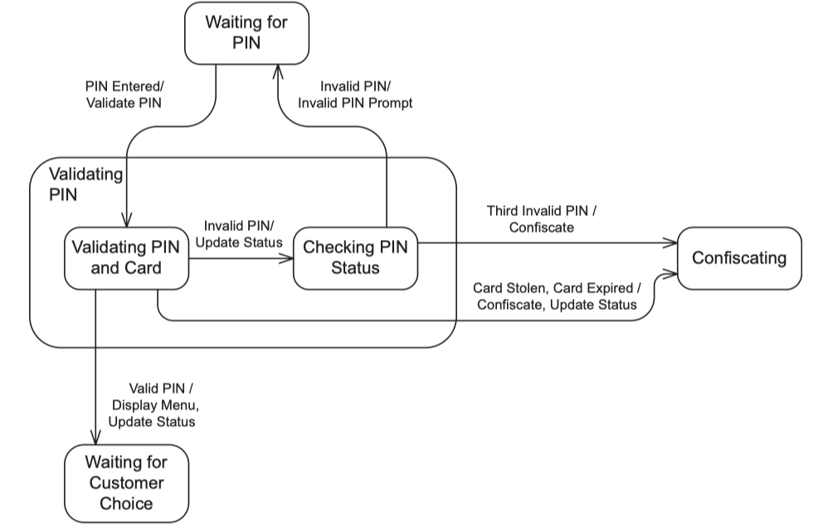

2.2 …

3. Detailed Design

3.1 <Feature/Function Name1>
[Provide the detailed design for the feature <Feature Name1>. It includes Class Diagram and Sequence Diagram(s); For the features/functions with the same structure of class & sequence diagrams, you need to provide the diagrams once for one feature/function and refer to those diagrams from other features/functions]

3.1.1 Class Diagram
[This part presents the class diagram for the relevant feature]
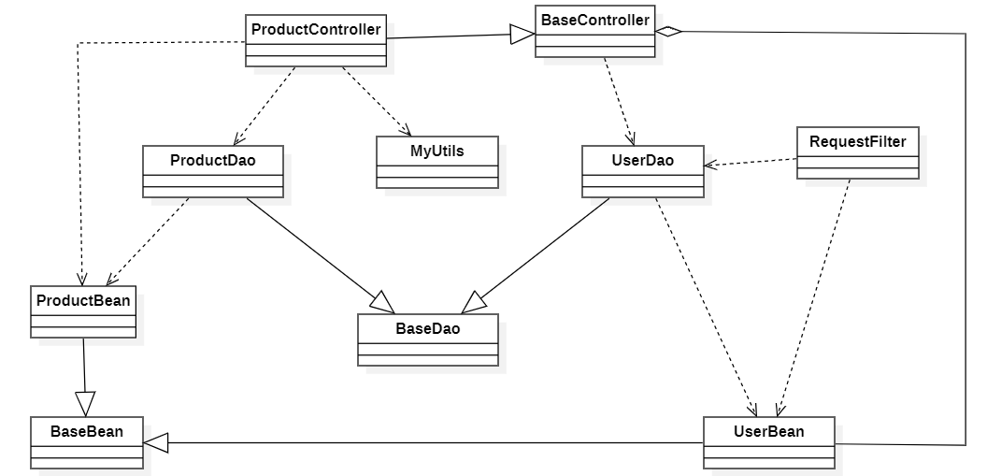

3.1.2 <Sequence Diagram Name1>
[Provide the sequence diagram(s) for the feature, see the sample below]
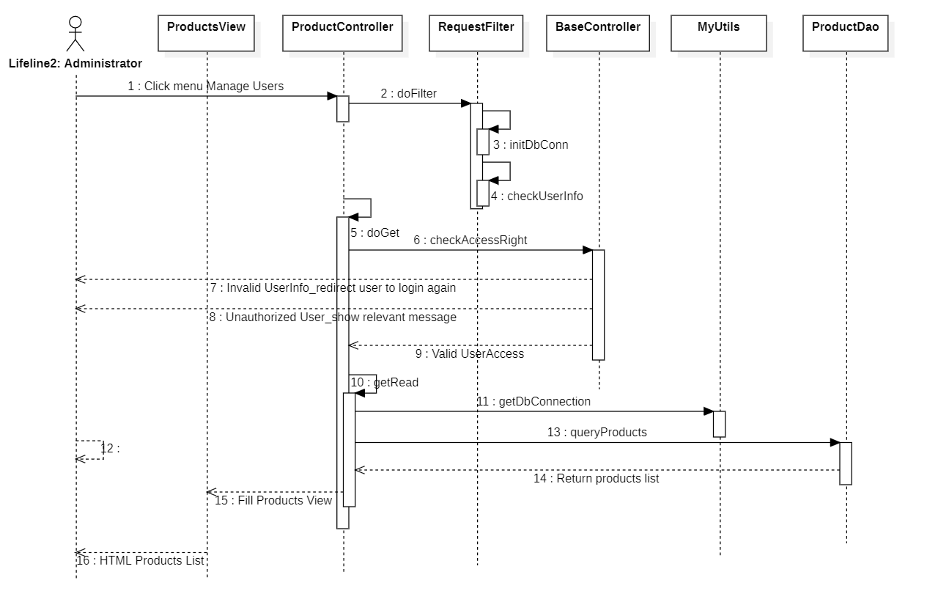

3.1.3 <Sequence Diagram Name2>

3.1.4 …

3.2 <Feature/Function Name2>
…

